**Practical Robotics Projects with Arduino**

**(CSE 4571)**

**Lab Assignment No – 07**

**NeoPixel Ring Programming**

**Submission Date: _______________**

|  |  |  |
| --- | --- | --- |
| **Branch: CSE Section:** | | |
| **Name** | **Registration No.** | **Signature** |
|  |  |  |

Department of Computer Science and Engineering

Institute of Technical Education and Research (Faculty of Engineering)

**Siksha 'O' Anusandhan (Deemed to be University)**

**Bhubaneswar, Odisha-751030.**

# Aim:

# NeoPixel Ring Programming – To Program a WS2812B NeoPixel LED Strip with Arduino UNO using the Adafruit library for multicolor and brightness effects.

# Objectives:

1. **Gain familiarity with the WS2812B NeoPixel LED strip.**
2. **To write an Arduino code that controls individual pixel colours using setPixelColor().**
3. **Write an Arduino sketch to explore brightness control of a WS2812B NeoPixel 16 LEDs in a strip using the setBrightness() function. This function will control the global brightness based on user input from a push button.**
   1. **Write an Arduino sketch to control the 5 different global brightness levels based on user input from a push button.**
   2. **Write an Arduino sketch to control the brightness fades UP and DOWN smoothly each time the button is pressed, instead of jumping in steps. (1st press fade UP, 2nd press fade DOWN, 3rd fade UP again and so on).**
4. **To develop an Arduino sketch that generates static multi-colour patterns on the LED strip.**
5. **To develop Arduino code for multi-colour effects such as rainbow, fading, and chasing animations.**

# Pre-Lab Questionnaire:

**A. Experiment-Specific**

1. What is the WS2812B LED commonly called in Adafruit terminology?
2. Which communication protocol is used by WS2812B LEDs?
3. Why is an external resistor (≈330–470 Ω) recommended on the data line of NeoPixels?
4. Why is a capacitor (≈1000 µF) recommended across the LED power supply?
5. What Arduino library is most commonly used to control WS2812B LEDs?
6. Which Arduino UNO pin is commonly used as the data pin for NeoPixels in example codes?
7. How many bytes are required to represent the color of one WS2812B LED?
8. Why must we call pixels.begin() in the setup function?
9. What power supply voltage is typically needed for WS2812B LEDs?
10. What is the typical maximum current consumption of one WS2812B LED at full brightness white?

# Components/Equipment Required:

|  |  |  |  |
| --- | --- | --- | --- |
| **Sl.**  **No.** | **Name of the**  **Component / Equipment** | **Specification** | **Quantity** |
| **1)** | Arduino UNO R3 | 16MHz | 1 |
| **2)** | Arduino UNO cable | USB Type A to Micro-B | 1 |
| **3)** | WS2812B NeoPixel 16 LED strip | Any colour of your choice | 1 |
| **4)** | Breadboard | 840 Tie points | 1 |
| **5)** | Jumper Wire | --------------------------- | As per requirement |

**Objective 2**

**To write an Arduino code that controls individual pixel colours using setPixelColor().**

## Circuit / Schematic Diagram

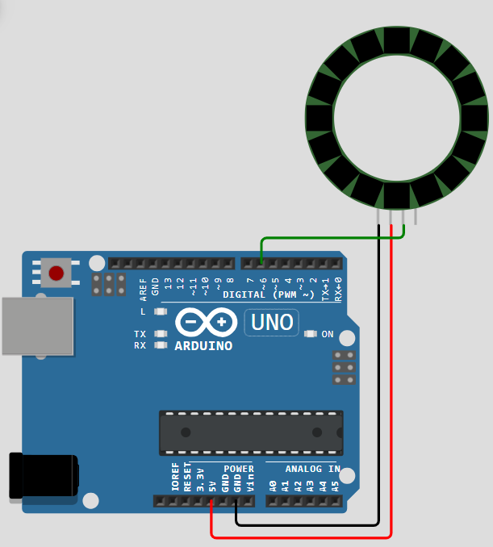

**Figure 1: Controls of individual WS2812B NeoPixel colours**

## Code

**Write an Arduino code that controls individual pixel colours using setPixelColor().**

## Observation

**Figure 2: (Simulation-based controls of individual WS2812B NeoPixel colours)**

# Objective 3

**Write an Arduino sketch to explore brightness control of a WS2812B NeoPixel 16 LEDs in a strip using the setBrightness() function. This function will control the global brightness based on user input from a push button.**

## Circuit / Schematic Diagram

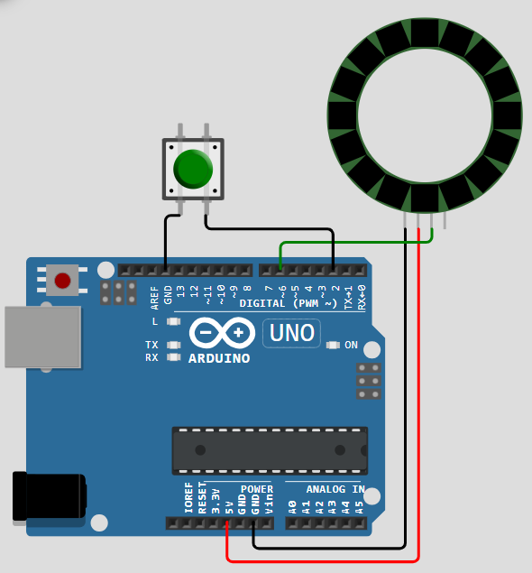

**Figure 3: Brightness control of a WS2812B NeoPixel 16 LEDs in a strip**

## Code

* 1. **Write an Arduino sketch to control the 5 different global brightness levels based on user input from a push button.**
  2. **Write an Arduino sketch to control the brightness fades UP and DOWN smoothly each time the button is pressed, instead of jumping in steps. (1st press fade UP, 2nd press fade DOWN, 3rd fade UP again and so on).**

**Observation**

**Figure 4: (Simulation-based brightness control of a WS2812B NeoPixel 16 LEDs in a strip)**

# Objective 4

**To develop an Arduino sketch that generates static multi-colour patterns on the LED strip.**

## Circuit / Schematic Diagram



**Figure 5: Static multi-colour patterns on the LED strip**

## Code

**Write an Arduino sketch that generates static multi-colour patterns on the LED strip**

## Observation

**Figure 6: (Simulation-based Static multi-colour patterns on the LED strip)**

# Objective 5

**To develop Arduino code for multi-colour effects, such as rainbow, fading, and chasing animations.**

## Circuit / Schematic Diagram



**Figure 7: Multi-colour effects on the LED strip animation**

## Code

**Write an Arduino code for multi-colour effects, such as rainbow, fading, and chasing animations**

## Observation

**Figure 8: (Simulation-based multi-colour effects on the LED strip animation)**

**Figure 9: (Hardware Implementation based multi-colour effects on the LED strip animation)**

**Conclusion:**

**Precautions:**

**Post Experiment Questionnaire:**

1. What function is used to actually display the updated color values on the NeoPixel LEDs?
2. How do you set the brightness of all NeoPixels in the strip?
3. Which function is used to assign an RGB color value to a particular pixel?
4. What happens if you set pixel colors but forget to call pixels.show();?
5. What was observed when brightness was set to maximum for multiple LEDs?
6. How can you create a color-changing rainbow animation on NeoPixels?
7. What color order (RGB/GRB) did your NeoPixel strip use in the experiment?
8. What practical limitation did you observe when using Arduino UNO for NeoPixel control?

**Answers to Post-Lab Questions**

___________________________________________

|  |  |
| --- | --- |
| **(Signature of the Faculty)** | **(Signature of the Student)** |
|  | **Name:** |
| **Date:** | **Registration No.:** |
|  | **Branch:** |
|  | **Section** |